**厦门迪太进出口有限公司**

**XIAMEN DITAI IMP.& EXP. CO.,LTD**

**地址：****中国厦门禾祥西路鸿升大厦8A**

**8FL, Hongsheng Building, West Hexiang Road, Xiamen, Fujian, China**

**TEL:0592-26808108 Phone:+8615160094689 FAX:0592-2680880 E-mail: irene.zhang@xmditai.com**

**----------------------------------------------------------------------------------------------------------------------**

**Calcium Citrate Food Additive CAS 813-94-5**

**Calcium Citrate Food Additive CAS 813-94-5 Basic details**

Chemical Name: 2-hydroxypropane-1,2,3-tricaboxylate Ca3  
M. F.: Ca3(C6H5O7)2.4H2O  
M. W.: 570.50

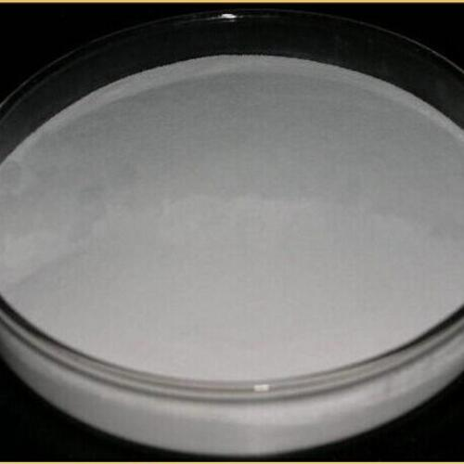

**Calcium Citrate Food Additive CAS 813-94-5 Physical properties**

White and odorless powder; hygroscopic slightly deliquescent; Hardly soluble in water and almost insoluble in Ethanol. When heated to 100°C, it will lose crystal water gradually; As heated to 120°C, the crystal will lose all of its crystal water.

**Calcium Citrate Food Additive CAS 813-94-5 Storage and transport**

To be stored in a dry and ventilative warehouse. Handle with care; Keep away from moisture, heat and poisonous substances

