厦门迪太进出口有限公司
XIAMEN DITAI IMP.& EXP. CO.,LTD
地址：中国厦门禾祥西路鸿升大厦8A
8FL, Hongsheng Building, West Hexiang Road, Xiamen, Fujian, China
TEL:0592-26808108 Phone:+8615160094689 FAX:0592-2680880 E-mail: irene.zhang@xmditai.com
----------------------------------------------------------------------------------------------------------------------
Ammonium Sulphate Caprolactam Grade CAS 7783-20-2
Ammonium Sulphate Caprolactam Grade CAS 7783-20-2 Product Description
Item name : Ammonium Sulphate /Ammonium Sulfate
Molecular Formula: (NH4)2SO4
Appearance: cololess crystal or white granular
CAS No.: 7783-20-2
EINECS No.: 31-984-1
Molecular Weight: 132.14
Purity: N 21%min
Grade : Caprolactam grade
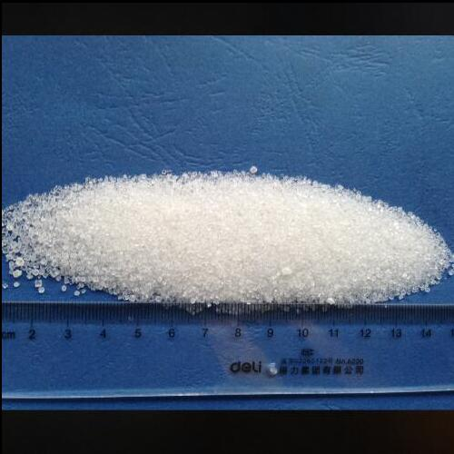
Ammonium Sulphate Caprolactam Grade CAS 7783-20-2 Packaging
Packaging Detail: 25kg/bag, 50kg/bag
Ammonium Sulphate Caprolactam Grade CAS 7783-20-2 Storage
Kept in dry and ventilating place, avoid moisture, water, rain and fire. Avoid shipment with acid, alkali class, edible orange mix of chemicals. Common transportation tools.

