**厦门迪太进出口有限公司**

**XIAMEN DITAI IMP.& EXP. CO.,LTD**

**地址：****中国厦门禾祥西路鸿升大厦8A**

**8FL, Hongsheng Building, West Hexiang Road, Xiamen, Fujian, China**

**TEL:0592-26808108 FAX:0592-2680880 E-mail: irene.zhang@xmditai.com**

IMG_257

**Preservative Sodium Metabisulphite CAS 7681-57-4**

   1,Chemical Name: Sodium Metabisulfite

      2,Molecular Formula : Na2S2O5

      3,Molecular Weight: 190.09

      4,CAS: 7681-57-4

5,Character: White or yellow crystalline powder or small crystalline, it is soluble in water.

6,Usage: In food industry, it is used as bleaching agents, preservatives, loosen agents, antioxidants, color protecting agents and preservatives. The pharmaceutical industry is used for the production of chloroform, phenylpropane and benzaldehyde. The rubber industry is used as a coagulant. The printing and dyeing industry is used as a dechlorination agent for cotton bleaching and a cotton cooking agent. Tannery industry for leather treatment, can make leather soft, plump, tough, with waterproof, anti - folding, wear resistance and other properties

7,Packing: It is packed with polyethylene bag as inner layer, and a compound plastic woven bag as the outer layer. The net weight of each bag is 25kg.

8,Storage and Transport: It should be stored in a dry and ventilating warehouse. Be cautious to keep away from moisture and heat; unloaded with care, so as to avoid the damage. Furthermore, it should be stored separately from poisonous

substances.

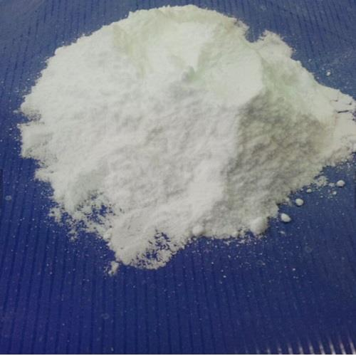​

Specifications for the product:

|  |  |  |  |
| --- | --- | --- | --- |
| Items | Index | | |
| Technical Grade | | Food Grade |
| Special | First |
| Na2S2O5 | 97% min | 96% min | 97% min |
| Iron ( Fe ) | 20ppm% max | 50ppm% max | 20ppm max |
| Water-fast material | 0.05% max | 0.05% max | -- |
| Heavy metal (Pb) | 0.001max | 0.005max | 5 ppm max |
| Arsenic ( As ) | 2 ppm % max | -- | 1 ppm max |

The Production Process of Sodium Metabisulfite:

Production technology of sodium metabisulfite line has two kinds of dry method and wet method

|  |  |  |
| --- | --- | --- |
| Project | Wet process | Dry process |
| production technology | mechanization high | process complex |
| product quality | high purity | low purity |
| raw material consumption | less | more |